Untitled

knitr::opts_chunk$set(echo = TRUE)

# Effect of Vitamin C on Tooth growth in Guinea Pigs

### David Pellon

### June 2017

## Overview:

### The objective of this study is comparing the tooth growth in Guinea Pigs depending on different diets and supplements.

## Load the ToothGrowth data and perform some basic exploratory data analyses:

### Loading data

library(datasets)  
data("ToothGrowth")

### Exploring data

head(ToothGrowth)

## len supp dose  
## 1 4.2 VC 0.5  
## 2 11.5 VC 0.5  
## 3 7.3 VC 0.5  
## 4 5.8 VC 0.5  
## 5 6.4 VC 0.5  
## 6 10.0 VC 0.5

names(ToothGrowth)

## [1] "len" "supp" "dose"

summary(ToothGrowth)

## len supp dose   
## Min. : 4.20 OJ:30 Min. :0.500   
## 1st Qu.:13.07 VC:30 1st Qu.:0.500   
## Median :19.25 Median :1.000   
## Mean :18.81 Mean :1.167   
## 3rd Qu.:25.27 3rd Qu.:2.000   
## Max. :33.90 Max. :2.000

We have 60 guinea pigs. Each group of them received different doses of Vitamin C using either orange juice or ascorbic acid.

library(ggplot2)  
levels(ToothGrowth$supp)<-c("Orange Juice","Ascorbic Acid")  
ggplot(ToothGrowth,aes(x=factor(dose),y=len))+  
 facet_grid(.~supp)+  
 geom_boxplot(aes(fill=supp),show_guide=TRUE)+  
 labs(title="Tooth Length, Dosage, Type of Supplement")+xlab("Dose (mg)")+ylab("Length")

## Warning: `show_guide` has been deprecated. Please use `show.legend`  
## instead.

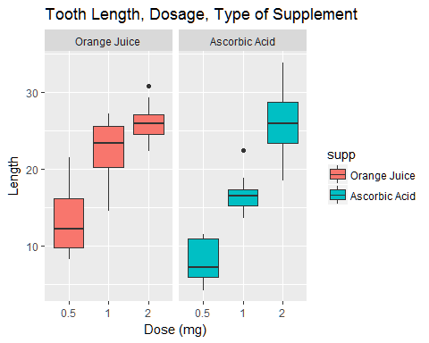

Guinea Pigs which received the Vitamin using Orange Juice had greater length. The dose effect when using Ascorbic Acid had a more dramatic impact on tooth length than when using Orange Juice.

## Use confidence intervals/hypothesis to compare:

### With different doses, both supplements bring same tooth growth

For 0.5

sset<-subset(ToothGrowth,dose ==0.5)  
h05 <- t.test(len ~ supp, data=sset)  
h05$conf.int

## [1] 1.719057 8.780943  
## attr(,"conf.level")  
## [1] 0.95

h05$p.value

## [1] 0.006358607

Hypothesis with 0.5 mg, OJ Growth = AA Growth - FALSE Hypothesis with 0.5 mg, OJ Growth > AA Growth - TRUE

For 1.0

sset<-subset(ToothGrowth,dose ==1.0)  
h10 <- t.test(len ~ supp, data=sset)  
h10$conf.int

## [1] 2.802148 9.057852  
## attr(,"conf.level")  
## [1] 0.95

h10$p.value

## [1] 0.001038376

Hypothesis with 1.0 mg, OJ Growth = AA Growth - FALSE Hypothesis with 1.0 mg, OJ Growth > AA Growth - TRUE

For 2.0

sset<-subset(ToothGrowth,dose ==2.0)  
h20 <- t.test(len ~ supp, data=sset)  
h20$conf.int

## [1] -3.79807 3.63807  
## attr(,"conf.level")  
## [1] 0.95

h20$p.value

## [1] 0.9638516

Hypothesis with 2.0 mg, OJ Growth = AA Growth - NOT FALSE (Cannot be rejected)

## Conclusions

Orange Juice offers more tooth growth except for 2.0 dose that is not clear. We assume that the data received is valid.